**Smart Vitals System Guidelines**

The smart vitals system is developed in such as way that it is easy to operate by the end users. The system works in a very simple way, the step-by-step guidelines on how user can access the system are listed below:

Step 1: The system turns on when the user plugs in the power bank module with the device.

Step 2: After the system is turned on, the user can view instructions on which button to press.

Step 3: User can press button 1 to activate MAX30102 sensor which gives the readings for Heart rate, SpO2, and blood pressure. The user should place their finger on the sensor properly to take measurement which is displayed on the OLED screen placed at top of the device.

Step 4: To take readings from another sensor user should press the button 1 again to deactivate the Max30102 sensor.

Step 5: User can press button 2 to activate ECG sensor. Once the ECG sensor is activated, the user should place the patches properly on the right arm, left arm and right leg for accurate waveform, which is then displayed on the OLED screen placed at top of the device.

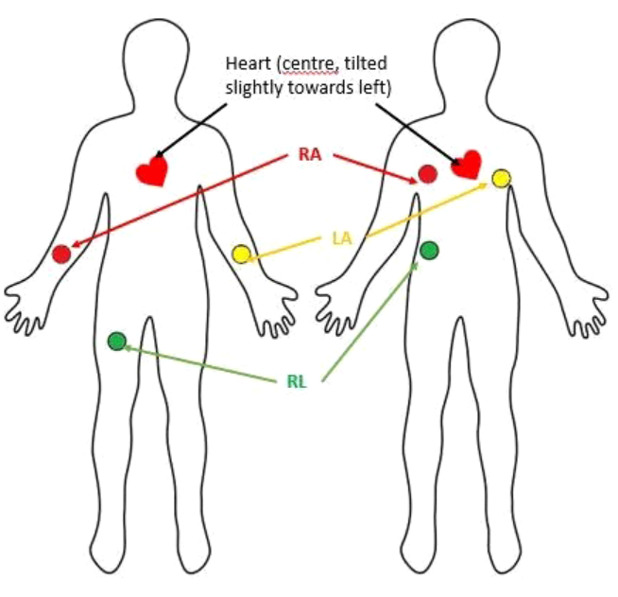

(Shah, 2021)

Step 6: Similarly, to take readings from another sensor user should press the button 2 again to deactivate the ECG sensor.

Step 7: User can press button 3 to activate Temperature sensor. Once the Temperature sensor is activated, the user should place the thermometer properly. It takes reading for one minute to give accurate reading. The readings from the temperature is seen on the OLED display.

Step 8: User can press the reset button whenever the user faces lagging problem.

Step 9: To charge the battery user can use the power bank module which they have used prior to initialize the system.